### **Orion Model (Main Model):**

A fusion of Visual and IoT models, providing comprehensive functionalities for tracking, analysis, prediction, and response.

#### A. Visual Model:

* **Human Detection**:
  + Technology: YOLOv7, SSD (Single Shot Multibox detector)
  + Description:
    - YOLOVv7: Detects and bounds humans within a scene. It can predict object categories and locations up to 45 fps.
    - SSD: Using the regression theory, the anchor box position and classification information of target information are directly regressed to the image.
    - YOLO series and SSD series algorithms can achieve a good balance between accuracy and speed. It adopts the regression theory strategy to achieve target detection.
  + Recommendation(s): Repulsion loss to solve the occlusion problem.
* **Individual Tracking and Overcrowding Detection**:
  + Technology: Kalman filter, ECC (Elliptic Curve Cryptography).
  + Description:
    - Kalman filter: Tracks individuals across frames and detects overcrowding based on proximity or bounding box count.
    - ECC: It provides a good solution for image encryption.
* **Collision Prediction**:
* Technology: Kalman filter, Bayesian deep classifier and deep learning algorithms
* Description:
  + Kalman filter: Predicts potential collisions between individuals based on future positions.
  + Bayesian deep classifier and deep learning algorithms: data are captured, and individual movements are analyzed using strategically arranged sensor nodes. Thorough testing, packet loss and communication collision rates are evaluated.
* **Activity Recognition** (Optional):
  + Technology: Pose estimation, 3D-CNN, or LSTM.
  + Description: Recognizes activities of individuals from visual data.

#### B. IoT Model:

* **Heart Rate Monitoring**:
  + Technology: IoT sensors.
  + Description: Monitors individuals' heart rates for safety and well-being.
* **Individual Tracking**:
  + Technology: GPS data or pinging.
  + Description: Tracks individual devices, storing the last location of lost devices.
* **Overcrowding Detection & Heatmap Generation**:
  + Technology: Clustering and Kernel Density Estimation (KDE), UAV
* Description:
  + Clustering and Kernel Density Estimation: Detects overcrowding by clustering devices and generates heatmaps from GPS data.
  + UAV: identifies crowd in any event which is seen by a camera equipped with an autonomous vehicle. Live camera to live stream of an image and uses ECC algorithm for a security check.
* **Collision Prediction**:
  + Technology: Predictive model using GPS data.
  + Description: Checks whether two devices are on a collision course.
* **Activity Recognition** (Optional):
  + Technology: IoT sensors like accelerometers, gyroscopes.
  + Description: Recognizes activities from sensor data.
* **Contact Tracing**:
  + Technology: Proximity data (GPS or pinging), graph-based model, 5G Thermal Imaging
  + Description:
    - GPS: Marks devices in proximity and builds chains of contact for tracing.
    - 5G Thermal Imaging: Thermal imaging to watch crowds. A cellphone is required to do contact tracing.

#### Additional Components:

* **Alert System**:
  + Description: Sends alerts for specific conditions like overcrowding or collisions through SMS.
* **Historical Analysis**:
  + Technology: Database system.
  + Description: Stores historical data for later analysis, including locations, alerts, predictions.
* **Emergency Evacuation Planning**:
  + Technology: Graph-based algorithms, possibly Multi-Agent Reinforcement Learning (MARL).
  + Description: Utilizes all data to plan optimal evacuation paths in emergencies.

**Diagram**

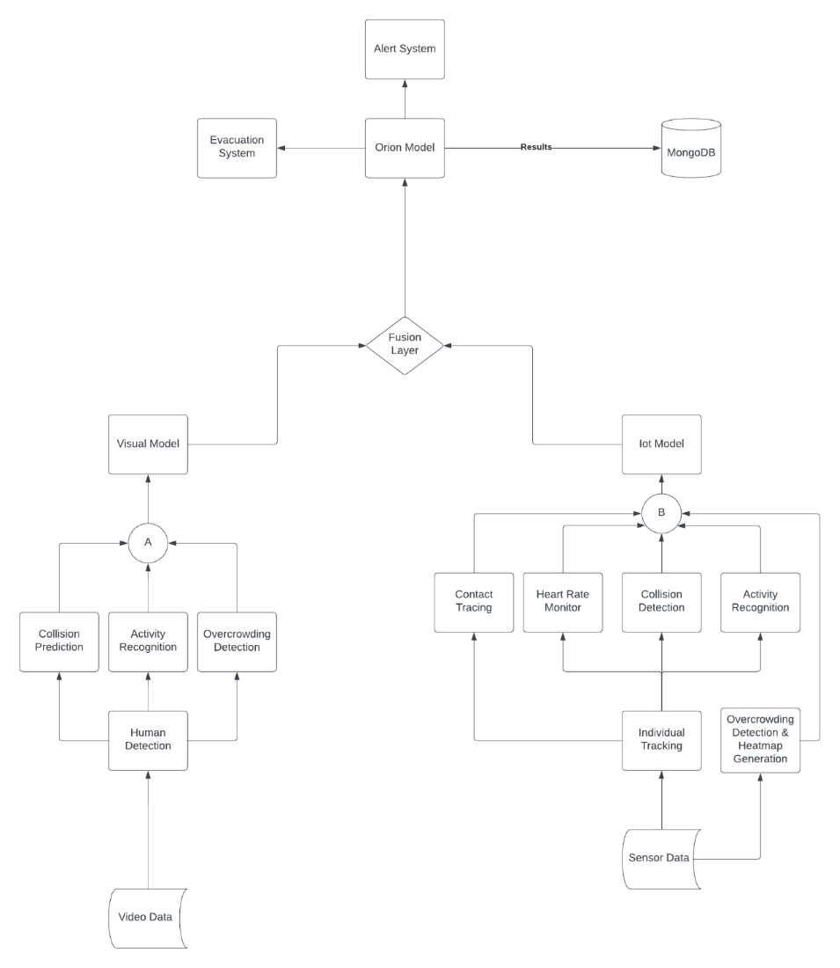

### **Summary:**

The Orion Model represents a comprehensive system that integrates visual and IoT data for a wide range of applications. It covers individual tracking, activity recognition, overcrowding detection, collision prediction, heart rate monitoring, heatmap generation, contact tracing, alerting, historical analysis, and emergency evacuation planning. By fusing these diverse functionalities, the system provides a robust and versatile solution for monitoring, analysis, and response in various contexts.